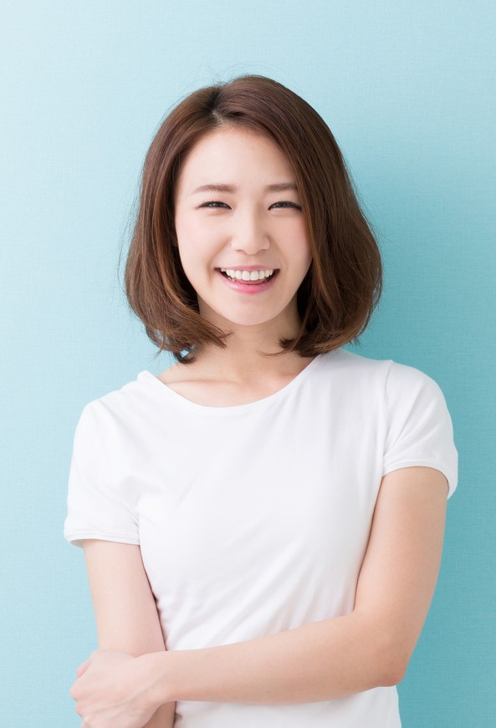

Cahaya

Dewi
Art Director
CONTACT
+123-456-7890
hello@reallygreatsite.com
123 Anywhere St., Any City reallygreatsite.com

ABOUT ME
Hello I am a pro Art Director. I have
a lot of experience in the creative industry

EDUCATION

Hight School
Class of 2011
Art University Bachelor Degree in Art Design 2012-2017

Design University
Master Degree in Art Design 2017-2020

WORK EXPERIENCES
Head Creative Aldenaire & Partners 2017 - 2018

Art Director Borcelle Studios 2018 - 2019

SKILL
Set Schedule Content Marketing

